This week I learned how to identify and create formulas for perpendicular lines. Perpendicular lines are any 2 lines that are exactly 90 degrees apart in orientation.

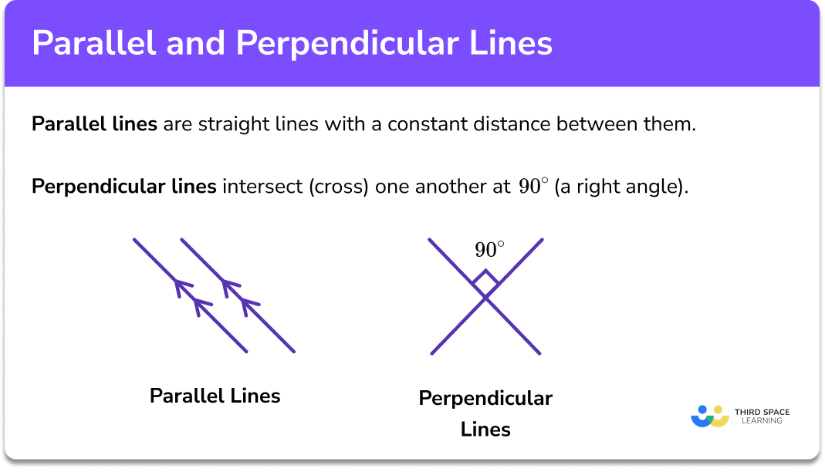

<https://thirdspacelearning.com/wp-content/uploads/2021/11/Parallel-and-Perpendicular-Lines-Featured-Image.png>

1.

Find the perpendicular line of one with a formula of y=3x+4

The first thing we must do is reciprocate the coefficient of x.

Our coefficient is 3, which doesn’t look like a fraction, but every number is secretly a fraction.

3 is the same thing as 3/1.

Now, we can reciprocate 3/1.

Our equation becomes y=1/3x+4

Finally, we flip the sign before our slope, meaning if the coefficient is positive, we make it negative, and vice versa.

Our final equation is y=-1/3x+4

If you graph this line, it will be exactly perpendicular to a line with a formula of y=3x+4

2.

Y=-1/4x-3

First, we reciprocate the coefficient.

¼ becomes 4/1, which is equal to 4.

Our equation becomes y=-4x-3

Now, we flip our sign. Since our original sign was negative, our final equation is y=4x+3

3.

Y=2/5x+2

First, we reciprocate our coefficient.

2/5 becomes 5/2.

Y=5/2x+2

Now, we flip the sign. In this case, we turn it from a positive to a negative.

Our final equation is y=-5/2x+2